August 16, 2026
Courtland Avenue’s “Spiritual Anchor”

“I serve you, Lord, and I am the child of one of your servants. Look on me with kindness. Make me strong and save me”. Psalms 86:16 (CEV)

WELCOME! We want you to know how happy we are that you took the time to visit us. Our desire is that you will find us to be a loving and caring family of God's children, who have Christ in our hearts, and displayed in our lives.
We hope you find visiting with us an uplifting experience, and our members to be friendly. We look forward to the opportunity to meet you. Please remain a few minutes after services that we might introduce ourselves. We desire to make your visit warm and pleasant. We don’t pretend to have all the answers, but all things pertaining to life and godliness has been revealed to us in the word of God (2 Peter 1:3).
Expect the worship to be simple and spiritual, consisting of singing spiritual songs, praying often, partaking of the Lord's Supper, teaching God's Word, and giving as we have been prospered. We seek to maintain the attitude Christ enjoined when He said, "God is a Spirit, and they that worship Him must worship Him in spirit and truth," (John 4:24).
Expect to find Christians only. We wear no distinctive name that would divide Bible believers. We submit to no religious authority other than the inspired scriptures. Thus, by following only the teachings of Christ and His Apostles, we are simply Christians (Acts 11:26), just as His disciples were in the first century. Again, thanks for attending our services.

Oglesby Jackson, Jr.,
Minister

Love will FIX 2026!

John 15:12 – “My command is this: Love
each other as I have loved you.”

601 East Courtland Avenue
Quitman, Georgia 31643
229-263-7154



Walter McCall
Oglesby L. Jackson, Sr.

Minister
Oglesby Jackson, Jr.

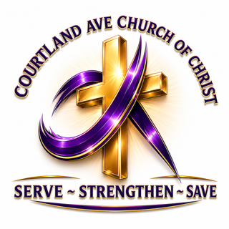


Sunday Bible Study ……………….………….9:45 am
Morning Worship ………..…….……...……11:00 am
Wednesday Bible Class……...................6:00 pm
Wed. Prayer ServiceS - Quarterly @ 6:00 pm


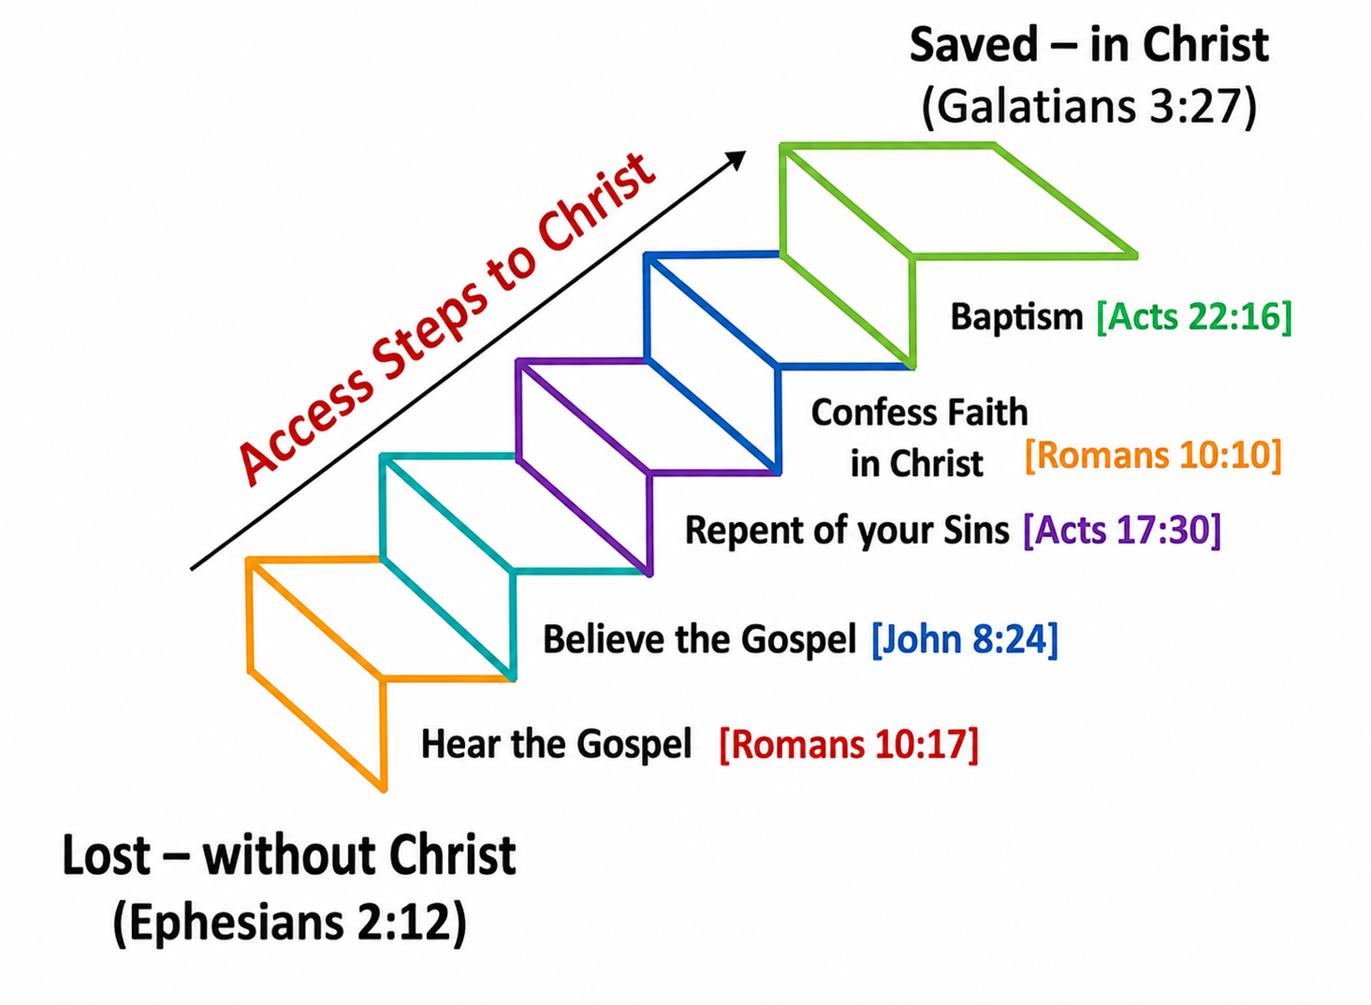


Benevolence ~ Bereavement ~ Building & Ground College & Young Adults ~ Education ~ Evangelism Jail ~ Search & Rescue ~ Senior Citizen
Technology & Social Media
Transportation ~ Youth



Patricia Glover - Placed Membership January 4, 2026
Tyler Burke – Baptized January 7, 2026
Jarrett Jackson – Placed membership January 11, 2026
Nicholas McGhee – Baptized January 15, 2025
Eugene McGhee – Baptized January 15, 2025
Rashad Hill – Baptized February 19, 2026
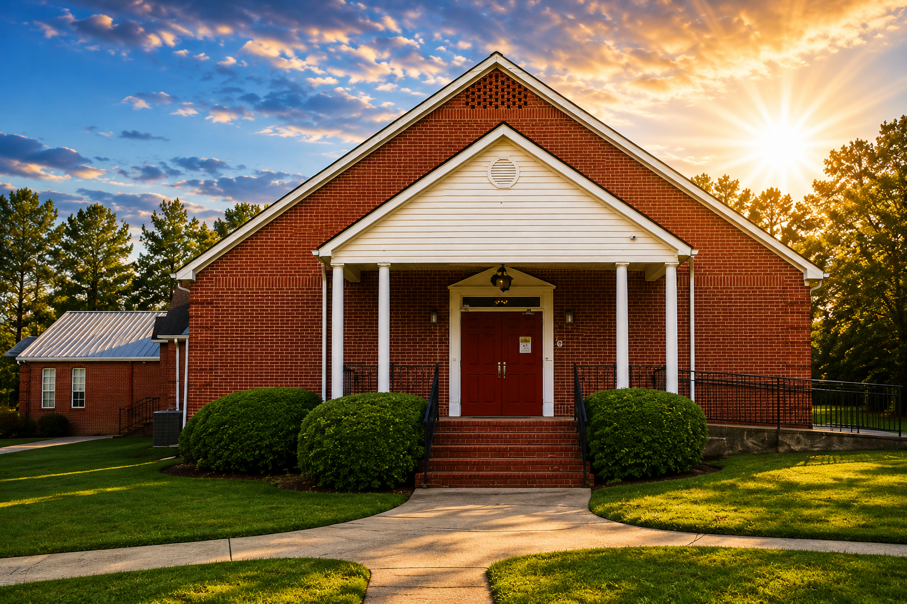




BIRTHDAYS
Cason Payne – August 7th
Jamaal Jackson – August 10th
Amiyah Brown – August 11th
Angeanette Nixon – August 12th
Justin Dunbar – August 12th
De’Cedric Adams – August 25th
Jeremy Jackson – August 30th

Minister’s Office Hours

Monday 1:00 pm to 4:00 pm
Tuesday 1:00 pm to 4:00 pm
Wednesday 1:00 pm to 6:00 pm
Thursday 1:00pam to 4:00 pm

Need a Ride to Worship? Contact:
Carlos Ashley – 229-415-8930
Mike Reynolds 229-230-771

Courtland Avenue Church of Christ New Website:

www.courtlandavecoc5.com

Courtland Avenue Online Giving:

THE NEW LINK FOR GIVING ↆ
https://swp.paymentsgateway.net/co/default.aspx?pg_api_login_id=584BB305AB


Scan QR Code for Giving:



ORDER OF SERVICE
Sunday, August 16, 2026

Welcome & Call to Worship
Bro. Walter McCall

Acts of Praise in Songs & Hymns
Bro. Victor Bush

Invitation To The Table
(COMMUNION & Offerings)

Bro. Carlos Ashley
Bro. Sam Jones
Bro. Mike Blake

Scripture & Prayer of Thanksgiving
Bro. Haywood Wright

Sermon
Bro. Oglesby Jackson, Jr.

Dismissal Prayer
Bro. Jarrett Jackson

Ushers
Bro. Mike Reynolds
Jamaal Jackson

We often assume we’re not supposed to make people feel guilty or ashamed. But understand that Christians who won’t take personal responsibility and obey the Word of God need to experience legitimate guilt. We must warn them and, if necessary, due to a refusal to repent, break our fellowship with them. Sometimes a brother needs a lesson.
You know you’re where God wants you to be when you are truthfully in his Word and he individually confirms it with his peace. Peace is harmony on the inside always in every way - that is, regardless of your circumstances.
Grace is God doing for you what you don’t deserve and can’t earn (Rom 11:6). It is his unmerited favor. You have an account in heaven, and God gives you the grace needed for today - but only for today. Nevertheless, it’s more than you’ll ever need.



- Sister Ruthie Arnold for upcoming surgery on August 18th.
- Mr. Jason Johns, in the passing of his father-in-law, Dr. Richard “Dick” Enstice of Melbourne, Fl. Memorial Services are August 22, 2026, at Brownie-Maxwell Funeral Home in Melbourne, Fl.
- Bro. Tyler Burke hospitalized at this time.
- Sister Essie Griffin is hospitalized in Thomasville, Ga., Prayers for Sister Shirley Griffin, her daughter.
- Mr. Calvin Williams and family in the passing of his son.
- Ms. Andrea Davis - loss of her son, Datavian Davis.
- Mr. Daniel Gosier
- Ms. Kim Robinson.
- Sister Betty Raines’s son, Mr. Troy Raines - receiving radiation treatments in Miami, Florida.
- Jax Sutton - ongoing medical treatments at Wolfson Children Hospital, Jacksonville, Florida.



- Free Haircuts for students up to age 18 Thursday, August 20th from 4:00 pm to 8:00 pm.
- August Visitation at the Fellowship Home is Saturday, August 22nd at 10:30 am.
- Monthly Birthdays and Anniversaries Celebration is August 28th after Wednesday Bible Class.
- Courtland Avenue Church of Christ Invites you to attend our Monthly "Love Story" Series - Romance Principle #4 – “The Matchmaker”, Ruth Chapter 4. Saturday, August 29th at 10:00 am. Lunch served after program. Sister Ernestine McCall is the Host.

Area Churches of Christ Announcements

- Woodlawn Forrest Church of Christ will celebrate their 96th Church Anniversary and Homecoming beginning Friday, September 4th at 7:00 PM with Speakers: Bro. David Wilson & Bro. Wesley T. Leonard. On Sunday September 6th at 9:00 AM - Speaker: Bro. Corey Glover 11:00 AM Speaker: Bro. David Wilson, and 3:00 PM Speaker: Bro. Marcus Watkins.
- Northside Church of Christ Ladies Day in Waycross, Ga. is Saturday, Sept. 19th. Theme: “Women in Warfare”. The Keynote speaker is Sis. Gloria Butler. Colors: Camo and pearls.
- The Southeastern Regional Lectureship is in Atlanta at the Crown Plaza Hotel and Convention Center, Oct. 5th - 8th, 2026. Website is: serlcoc.org.



The Importance of First Impressions

Sometimes when you meet a person there is just something about them that sets them apart from others. There are those negative people who impact us in such a way that we find it difficult to see their souls and the potential they may have in Christ. On the other hand, there are those to whom we are immediately attracted, and we want to get to know them better.
When God became man, He was like us in so many ways. He took on Himself the frailties of mortals, suffered like we do and was tempted in all ways like we are. However, the first impression He made on others could never be forgotten.
When He was only twelve years of age, He was separated from His parents, and they finally found Him in the holy temple talking to the religious leaders. The Bible says that when they found Him, He was “…sitting in the midst of the teachers, both listening to them and asking them questions. And all who heard Him were astonished at His understanding and answers” (Luke 2:46-47). The first impression He made greatly impacted all those who heard Him.
The same is true of the impression He had on the multitude who heard the Sermon on the Mount. “When Jesus had ended these sayings, the people were astonished at His teachings, for He taught them as one having authority, and not as the scribes” (Matt. 7:28-29). In His first discourse in the synagogue in Nazareth, “…all bore witness to Him, and marveled at the gracious words which proceeded out of His mouth” (Luke 4:22). Not all accepted His words in the city where He had grown up, and some of them sought to kill him by throwing Him over a cliff.
He left Nazareth and went and taught in the synagogue in Capernaum for several weeks. What was the impression He made there? “And they were astonished at His teaching for His word was with authority” (Luke 4:32). The story does not end here. Read the gospel account of His life. It happens again and again.
We may not always make the kind of impression Jesus did everywhere He went, but the very fact that we know Him impacts how others see us. Salt that is really salty and light that is not hidden under a bushel impacts all that they touch. The impact that His apostles had on others shows this. Shortly after Pentecost they were arrested and brought before the Jewish counsel. The Bible says, “When they saw the boldness of Peter and John, and perceived that they were uneducated and untrained men, they marveled. And they realized that they had been with Jesus” (Acts 4:13). Think carefully about the first impression you make on others!



