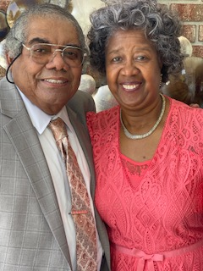
Oglesby was born and raised in Morven, Georgia and was baptized at Laurel Street Church of Christ at the age of 11. He received a BS degree from Valdosta State University and completed further studies at the University of Georgia. Oglesby was called to serve his country during the Vietnam war era.
Oglesby married his wife, Sarah, on April 21, 1968, and together they have three boys Oglesby, Jr. - presently minister at Courtland Avenue Church of Christ, Quitman, Ga.; Makaza - Food & Nutrition Services Operations and Human Resources Manager at Caramont Regional Medical Center, Gastonia, N.C.; Christopher- minister at Jackson Street Church of Christ, Nashville, Tn; and one daughter Felicia - Director of Pharmacy at Archbold Brooks County Hospital in Quitman, Ga.
Oglesby taught in the Lowndes County school system for 33 years and retired in 2006. He now totally cherishes any opportunity to sit across the table with somebody--familiar or stranger, young or old--and share the richness of life found in the pages of God's Word. He has been an Elder at Courtland Avenue since 2003. He presently oversees the Education Ministry. He has actively taught Adult and New Convert Classes since 1971.
Oglesby has a history of standing firm on God’s word. He will proclaim to anyone that Courtland Avenue Church of Christ is a very strong “Bible-based” church where families can grow spiritually and have fellowship with Christians who share the common goal of following God’s word, as it is written.

