

2026 Baptisms

Patricia Glover - Placed Membership January 4, 2026
Tyler Burke – Baptized January 7, 2026
Jarrett Jackson – Placed membership January 11, 2026
Nicholas McGhee – Baptized January 15, 2025
Eugene McGhee – Baptized January 15, 2025
Rashad Hill – Baptized February 19, 2026


BIRTHDAYS
Michael Blake – July 5th
Jermaine Dawson – July 11th
Mary McGhee – July 12th
Marquel Harrison- July 15th
Samuel Jones – July 18th
Juanita Ghee – July 22nd
Jacqueline Jackson – July 30th
Sarah Jackson – July 31st

ANNIVERSARIES:
The Late Andrew Jackson & Sister Deloris Jackson – July 2nd
Arthur & Betty Raines - July 5th (57 years)
Willie & Arridean Jackson – July 12th (63 years)

Minister’s Office Hours
Monday 1:00 pm to 4:00 pm
Tuesday 1:00 pm to 4:00 pm
Wednesday 1:00 pm to 6:00 pm
Thursday 1:00pam to 4:00 pm

Need a Ride to Worship? Contact:
Carlos Ashley – 229-415-8930
Mike Reynolds 229-230-7715

Courtland Avenue Church of Christ New Website:

www.courtlandavecoc5.com


Sunday Bible Study ……………….………….9:45 am
Morning Worship ………..…….……...……11:00 am
Wednesday Bible Class……...................6:00 pm
Wed. Prayer ServiceS - Quarterly @ 6:00 pm


GOD'S PART
- The great love of God for man (John 3:16)
- He gave His Son, Jesus Christ, as the Savior (Luke 19:10)
- Sent the Holy Spirit as a guide (John 16:13.
- Gave the Gospel as "the power" unto salvation (Romans 1:16)
- Provided atonement by the blood of Christ (Romans 5:9)
MAN'S PART
- Hear the Gospel. (Romans 10:17, John 8:32)
- Believe the Gospel (Hebrews 11:6, John 20:31)
- Repent of past sins (Luke 13:3, Acts 17:30)
- Confess faith in Jesus Christ (Romans 10:10, Matthew 10:32)
- Be Baptized (Gal. 3:27, Mark 16:16, Acts 2:38)
- Be faithful unto death (Revelation 2:10)

God has done His part; will you do yours?


Benevolence ~ Bereavement ~ Building & Ground College & Young Adults ~ Education ~ Evangelism Jail ~ Search & Rescue ~ Senior Citizen
Technology & Social Media
Transportation ~ Youth


July 26, 2026

Courtland Avenue’s “Spiritual Anchor”

“I serve you, Lord, and I am the child of one of your servants. Look on me with kindness. Make me strong and save me”. Psalms 86:16 (CEV)


WELCOME to Courtland Avenue Church of Christ. Your presence is uplifting and edifying for us. Courtland Avenue members are ordinary people just like you – people who meet to worship God and grow in knowledge of and love for our Lord and Savior Jesus Christ. We are delighted your spiritual journey has brought you here today.

Curtland Avenue is a sovereign body, with Christ only as our head, and elders shepherding the flock of God (Acts 20:28). We have been entrusted with the Gospel (1 Thessalonians 2:4), and so it is that we speak. The congregation seeks to uphold the doctrine and practice of the first century church using the bible, as our guide (2 Peter 1:3).

Our plea is that we all would come to a knowledge of the truth, become one in Christ (John 17:21), be immersed in baptism for the remission of sins (Acts 2:38), strive to keep the unity of the spirit in the bond of peace (Ephesians 4:3) and serve the Lord faithfully unto death to receive our crown (Rev 2:10).

We sincerely pray that you find a home here with us at Courtland Avenue Church of Christ, and with God in Heaven as his child. (I Corin. 2:2) “To Know Him and make Him known”.

Oglesby Jackson, Jr.,
Minister

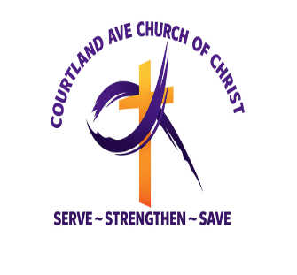
Love will FIX 2026!

John 15:12 – “My command is this: Love each other as I have loved you.”

601 East Courtland Avenue
Quitman, Georgia 31643
229-263-7154



Walter McCall
Oglesby L. Jackson, Sr.

Minister
Oglesby Jackson, Jr.

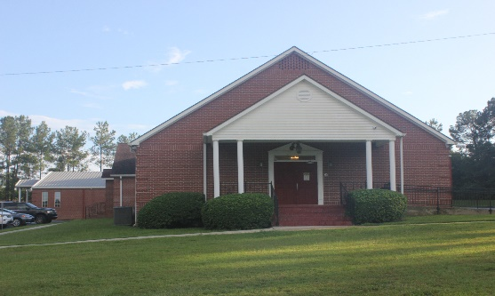

Courtland Avenue Online Giving:



THE NEW LINK FOR GIVING ↆ
https://swp.paymentsgateway.net/co/default.aspx?pg_api_login_id=584BB305AB

Scan QR Code for Giving:

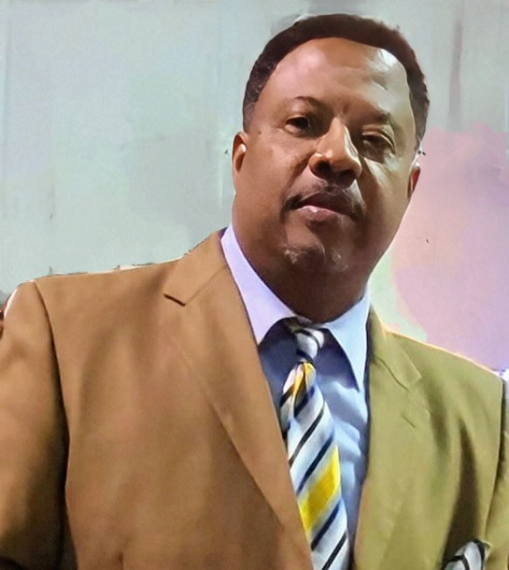

ORDER OF SERVICE
Sunday, July 26, 2026

Welcome & Call to Worship
Bro. Oglesby Jackson, Sr.

Acts of Praise in Songs & Hymns
Bro. Victor Bush

Invitation To The Table
(COMMUNION & Offerings)

Bro. Carlos Ashley
Bro. Tyler Burke
Bro. Mike Blake

Scripture & Prayer of Thanksgiving
Bro. Haywood Wright

Sermon
Oglesby Jackson, Jr.

Dismissal Prayer
Bro. Jarrett Jackson

Ushers
Bro. Mike Reynolds
Jamaal Jackson

To whom Will you compare Me? Who is My Equal? Asked The Holy One.
Isaiah 40:18

Isaiah asks a great question—who is like God? In Isaiah’s day, the thought was intended to show that the idols and false gods that Israel was running to was really nothing. These gods were fake. They had no life. A craftsman carved images out of a tree and the nation fell down and worshipped that manmade image. The prophet declares, “The Everlasting God, the Lord, the Creator of the ends of the earth does not become weary or tired. His understanding is beyond belief. He gives strength to the weary.”
There is no one like God. There is nothing as Holy as God. There is nothing as powerful as God. There is no one as good and merciful as God. There is nothing as just as God. God is. He told Moses that His name was “I Am.” I AM God!
In Acts Peter preached, “There is no other name under Heaven that has been given among men by which we must be saved.” There is no one but God.
So often God is the last one we go to. We’ll take our problems to family, friends, counselors and a host of other people, even listening to the advice of strangers on TV or the radio before we bow in prayer and give it to God. Peter said, “cast all your anxiety upon Him, because He cares for you.” It was that same Peter, who years before in a boat amidst a storm, woke Jesus up declaring frantically, “Lord, do you not care that we are perishing?” He learned. God cares. He learned. There is no one like the Lord.
God is not like man. He doesn’t act like we act, think like we think nor respond the way we respond. He is God. He doesn’t forget the promises He makes. He doesn’t change His mind. He forgives and lets go. He blesses us when we do not deserve it. He thinks of us when we do not think of Him. He never gives up on you. He chases you to get you to come back to Him.
The modern church in far too many places have left God and is interested in thrilling man and pleasing man and doing what man wants. It’s not about us, it’s about God. God ought to fill our hearts and our minds. We ought to want to praise Him, follow Him, obey Him and honor Him. Great is our God, the Psalmist would declare. Once you have met God through faith, you will never meet anyone else that is like Him!

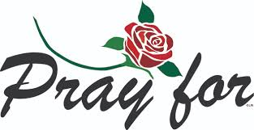

- Sister Alice Mitchell’s father.
- Sister Betty Raines’s son, Mr. Troy Raines. Now receiving radiation treatments in Miami, Florida.
- Jax Sutton - ongoing medical treatments at Wolfson Children Hospital, Jacksonville, Florida.



- Brother Sam Jones is visiting in Maryland with his children and grandchildren. Prayers for his safe trip back to Quitman.

- Monthly Birthdays and Anniversaries is July 29th after Bible Class.

- Funeral services for Sister Fannie Marie Jackson Gibbs are Saturday, August 8th at Stevens McGhee Funeral complex.

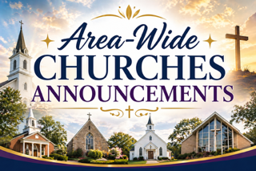

❦ 41 South Church of Christ Ladies Day Program in Valdosta, Ga.
is Saturday August 15, 2026. Speakers are Sister Andrea Scott
and Sister Dorothy Dye of Newsome Street Church of Christ.

❦ Northside Church of Christ Ladies Day program in Waycross,
Ga. is Saturday, Sept. 19th. Theme: “Women in Warfare”. The
Keynote speaker is Sis. Gloria Butler. Colors: Camo and pearls.

❦ The Southeastern Regional Lectureship is in Atlanta at the
Crown Plaza Hotel and Convention Center, Oct. 5th - 8th, 2026.
Website is: serlcoc.org.



